Sunday Service – 6 September

SUNDAY MORNING WORSHIP WITH REV. NEIL GLOVER – TENANDRY KIRK

Traditional YouTube | Sunday morning onwards | https://www.youtube.com/channel/UCpA-Ianua69JOCtTV2zBDxw
Traditional Dial-In | Sunday morning onwards | Dial 01887 440446
Contemporary YouTube | Sunday morning onwards | https://www.youtube.com/channel/UCpA-Ianua69JOCtTV2zBDxw
Contemporary Zoom | 10.30am | https://us02web.zoom.us/j/83009650276  Meeting ID: 830 0965 0276  Password: 504415
Post-service Zoom coffee and biscuits | 11.30am | https://us02web.zoom.us/j/83009650276  Meeting ID: 830 0965 0276  Password: 504415

FUNERALS

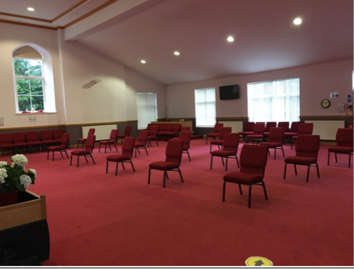

Aberfeldy Church is now available for funerals. All funerals will follow the current Scottish Government Guidelines, this limits the numbers to a maximum of 20 mourners. The photograph above shows the stark reality of 20 chairs spaced 2 metres apart. Gaulds will reposition the chairs to suit the individual family’s requirements.

The first funeral will be for:

Margaret Carmichael
on Wednesday 9 September 2020
at Aberfeldy Parish Church - 11.30am

All details from Gaulds Funeral Services - 01887 820436

VIRTUAL KILTWALK EVENTS for CAP Highland Perthshire

CAP HIGHLAND PERTHSHIRE supporters are limbering up to participate in a number of fund-raising events for the CAP Highland Perthshire Debt Centre between 11th and 13th September.

Will you help us smash our fundraising target?

Who ‘s in the Team? Angela Hanvey, Dorothy Edwards, Elizabeth Stenhouse, Katie Allstaff, Matt Collins, Akosita, Sox and Junior Soqueto and Neil Glover.

What challenges are they undertaking? Various – some are walking between 6 - 12 miles locally, others are canoeing on the Tay, climbing Schiehallion or paddleboarding the length of Loch Tay.

What’s their fund-raising target? Jointly, £2,500 but each team member has set his or her own target. BUT - we’re hoping to smash this by a considerable amount and we’d love you to help us do it.

The brilliant news is that Sir Tom Hunter has pledged to add 50% from the Hunter Foundation to whatever total each team member raises. What a bargain!!

How do I help you smash the target? Click on the link below to choose one of the team members to sponsor.

https://edinburghkiltwalk2020.everydayhero.com/uk/team-cap-highland-perthshire

You can donate online to an individual – just click on their picture or name to go to their donation page. Or you can give a donation to the individual you’re choosing to support and they’ll deposit it as an offline donation into the Kiltwalk account.

Thanking you in advance for your generous support and thanks to everyone who has already sponsored one of us.

YouTube Online Services

Neil, Geoff and Robert would like to express their gratitude to all those who have assisted in these services over recent months and who have offered to support the Ministry Team in the future, as they plan what this might look like!

I am sure we all recognise that none of these services would have been possible without Jamie and the considerable expertise he brings to these services. There are times when the technology can be particularly challenging. Thank you Jamie for persevering!

Neil’s return to work and days off

Neil is now back working full time work.

Please note his days off are generally Mondays and Saturdays

Contact details

email - nglover@churchofscotland..org.uk

mobile – 07779 280074

PA – Judy Ewer – judy.ewer@adwgls.org.uk

Mobile – 07836 565528

