The Parish Church of Dull & Weem
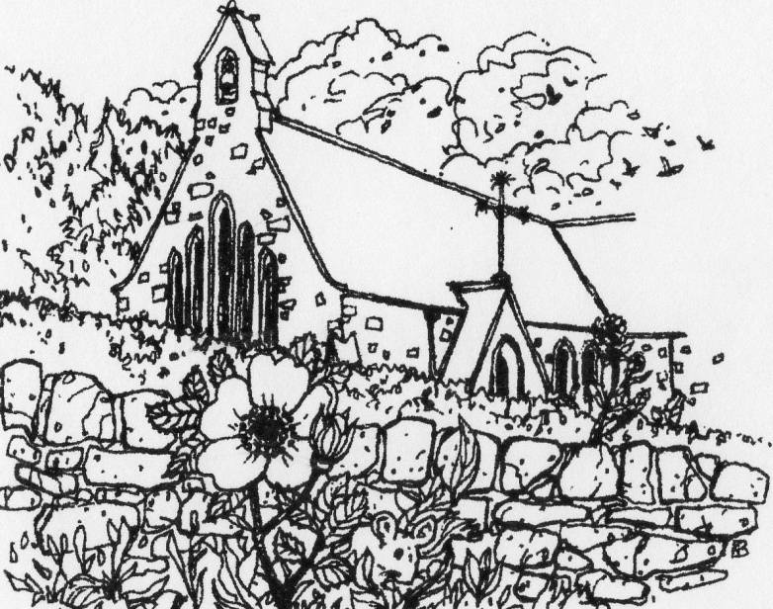

Order of Service 11 October 2020 - 0930am
Welcome
Call to Worship
Music
Prayers of Approach and Confession
Scripture Reading Psalm 137: 1-6
By the rivers of Babylon we sat and wept when we remembered Zion. There on the poplars we hung our harps, for there our captors asked us for songs, our tormentors demanded songs of joy; they said, “Sing us one of the songs of Zion!
How can we sing the songs of the Lord while in a foreign land? If I forget you, Jerusalem, may my right hand forget its skill. May my tongue cling to the roof of my mouth if I do not remember you, if I do not consider Jerusalem my highest joy.
First Thought
Music
Scripture Reading Psalm 91: 1-16
Whoever dwells in the shelter of the Most High will rest in the shadow of the Almighty I will say of the Lord, “He is my refuge and my fortress, my God, in whom I trust.”
Surely he will save you from the fowler’s snare and from the deadly pestilence.
He will cover you with his feathers, and under his wings you will find refuge; his faithfulness will be your shield and rampart. You will not fear the terror of night, nor the arrow that flies by day, nor the pestilence that stalks in the darkness, nor the plague that destroys at midday. A thousand may fall at your side, ten thousand at your right hand, but it will not come near you. You will only observe with your eyes and see the punishment of the wicked.
If you say, “The Lord is my refuge,” and you make the Most High your dwelling, no harm will overtake you, no disaster will come near your tent. For he will command his angels concerning you to guard you in all your ways; they will lift you up in their hands, so that you will not strike your foot against a stone. You will tread on the lion and the cobra; you will trample the great lion and the serpent.
“Because he loves me,” says the Lord, “I will rescue him; I will protect him, for he acknowledges my name. He will call on me, and I will answer him; I will be with him in trouble, I will deliver him and honour him. With long life I will satisfy him and show him my salvation.”

Sermon
Music
Prayers of Thanksgiving and Intercession
Music
Benediction

