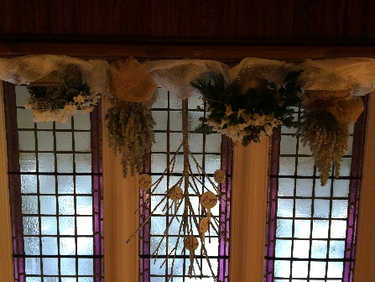
John 1: 43-51
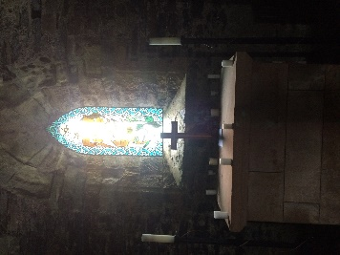
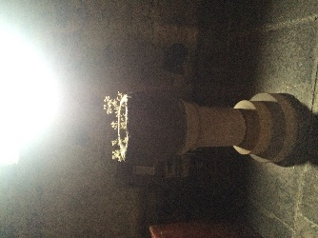

Over these last few days, we have probably spent time “looking out our window”- seeing snow, sunshine, and watching nature. Windows allow us to do this and they let light in. We can “look out”, we can say “come and see” from our windows.
In today’s story (John1: 43-51) we have Jesus in Galilee as he meets Philip and says to him, “Follow me”. Philip invites his friend Nathanael to come and find out about Jesus- Philip says “come and see”. Nathanael is not enthusiastic but realises Jesus seems to know him already.
When we invite others to “come and see” God, we are sharing a bit of our lives in how we behave, how we speak to others, how we deal with differences and it reveals our faith. The task today is: look out of your window- draw something that you see (you can use the template) and/or if you have not already, but would like to, sign up to the RSPB Bird watch event, then do so now using this link: https://www.rspb.org.uk/get-involved/activities/birdwatch/everything-you-need-to-know-about-big-garden-birdwatch/ (perhaps you are doing this through school already). Encourage others to join in …and as you watch the wonder of nature out your window, think about the wonder of God that awaits us all. Send a photo of your drawing to us here on our facebook page or to our website.
